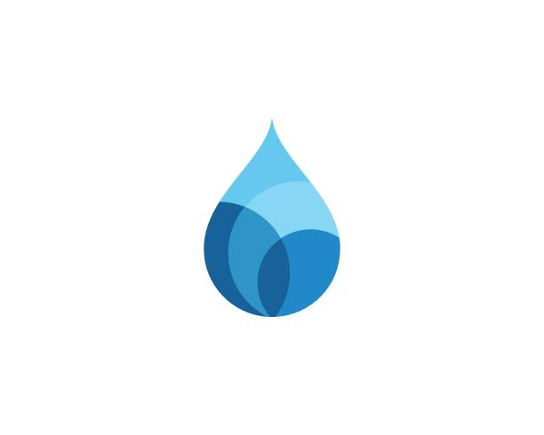
Somerset Domestic Waterworks District
3764 Highway 133
P.O. Box 549
Somerset, CO 81434
(970) 929-5211

This is a recording transcript from SDWD's Zoom Meeting held on December 3rd at 6:31 p.m. for the Sunset Domestic Water District board meeting.

Key Topics Discussed:

Budget Adjustments:
- Approved preliminary budget with modifications: moved $1,000 from water meter reading ($6,000 down to $5,000) to attorney fees ($0 up to $1,000)
- Final budget due January 15th

Water Quality & Compliance:
- Failed copper test due to spring water quality changes
- Plan: Continue CL50 treatment and conduct additional water testing to meet state requirements by December 31st deadline
- Long-term considerations: potential well or upper tank installation

Administrative Updates:
- Retained an SDA attorney (Danielle from a Glenwood-based firm) at $200/hour; initial consultation cost $350
- Developing open records request policy to establish clear guidelines for public information requests
- Implementing secure password management system for all district accounts
- Removed QuickBooks payroll service (saving $600/year) since Christine works as a 1099 contractor

Grant & Infrastructure:
- $111,000 OCT grant allocated: $10,000 for cameras, $21,000 for pressure differentials, remaining funds for meters/pits or valve replacements
- Oxbow tank project still under consideration; new bids needed
- River pump PLC card replacement (covered by Oxbow)

Other Items:
- Christmas party scheduled for December 20th at Community Building
- ATV use discussion for district maintenance (awaiting county commissioner response)
- November 22nd meeting minutes approved

