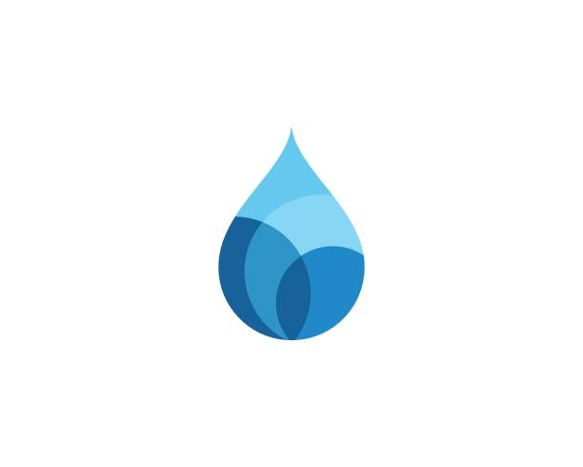
Somerset Domestic Waterworks District
3764 Highway 133
P.O. Box 549
Somerset, CO 81434
(970) 929-5211
Open Office Hours: Wednesdays 10:00-2:00

Board Meeting
Tuesday 12-30-25
6:30 pm

Call to Order:

Attendees:

Minutes:
Treasure Report:
Agenda:
Approval of Final Budget
Update on Bids (Grants)
Change Zoom to just Recording
Updates on Lead and Copper
Discuss Water District and Community Separation
Discuss Aggressive Dogs
Review and Approve Contract for Christine’s Professional Services
Approve access to Bank Account, view only, for Christine.

Questions and Concerns:
Adjournment:

